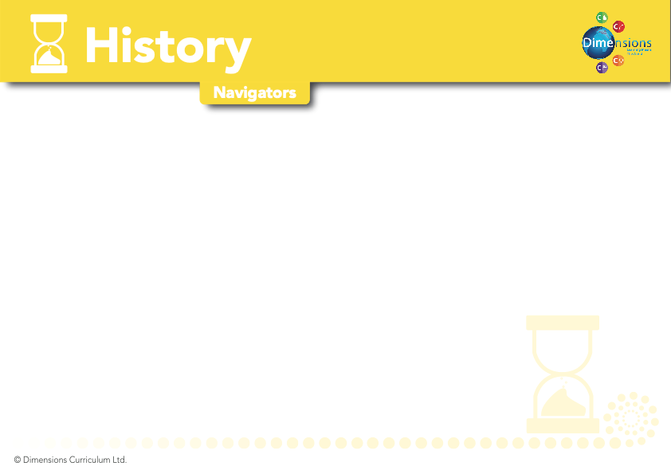
Y5-6

A WORLD OF BRIGHT IDEAS | MISSION CONTROL | WARS OF THE WORLD | YOU’RE NOT INVITED | COME FLY WITH ME! AMERICA | I HAVE A DREAM…
- To learn about important inventions from the past | - To learn about space exploration and discovery  - To develop knowledge and understanding of famous astronomers, as well as significant worldwide astronauts.  - To learn about the development and role of satellite communication | A study of an aspect or theme in British history that extends pupils’ chronological knowledge beyond 1066  - To know and understand why wars occur  - To learn about the two world wars and understand their impact  - To understand what a civil war is and have some knowledge of famous civil wars  - To know where current wars are taking place in the world  - To learn about pacifism and the concept of peace | Pupils should be taught about the Roman Empire  - To learn the meaning of the word ‘invasion’ and understand the possible reasons for and consequences of an invasion  - To know the location of Italy and the Roman Empire  - To understand why the Roman Army was so successful in their invasions  - To learn about some of the famous battles that took place during the Roman era  - To understand the impact of the Roman invasions on the inhabitants of those countries invaded | - To learn about the discovery of America  - To know about the Native Americans | - To learn the definition of apartheid  - To know about the Jim Crow Laws and how they affected black people  - To learn about Martin Luther King and the impact he had on society  - To become familiar with Nelson Mandela’s role in the anti-apartheid movement in South Africa  - To know about and understand other forms of discrimination e.g.  anti-semitism
National Curriculum Objectives =

