Swimming Data Holden Clough Community Primary School
As of April 2018, schools have the responsibility of publishing swimming data. This data should express how the children have met the National Curriculum expectations in KS2. By the end of Year 6 children should be able to:
- swim competently, confidently and proficiently over a distance of at least 25 metres
- use a range of strokes effectively
- perform safe self-rescue in different water-based situations.
As part of our recovery curriculum and PE action plan, Year 6 children received extra swimming lessons in the summer term to improve the number of children leaving school meeting the national curriculum requirements.
Details of children who have met curriculum objectives in Year 5/6 can be found below.
Year 6 cohort (Summer Term 2022)
Cohort of 60 children
Swimmer (Have met curriculum objectives) | 43%
Non-swimmer (Have not met curriculum objectives) | 57%

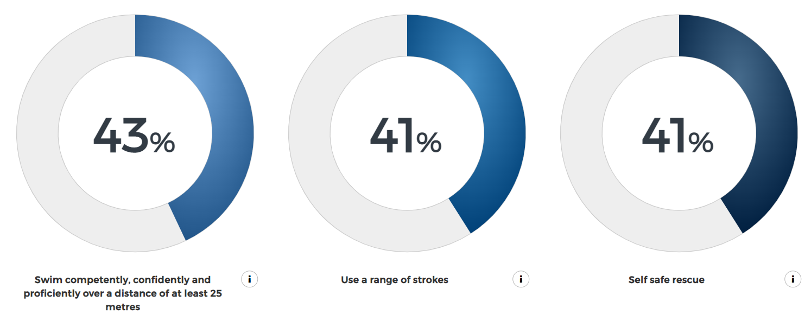

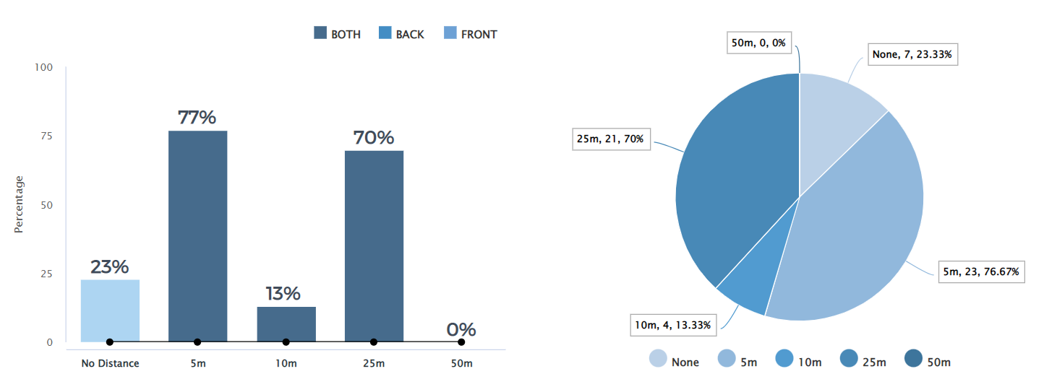
Swimming data class 6AH
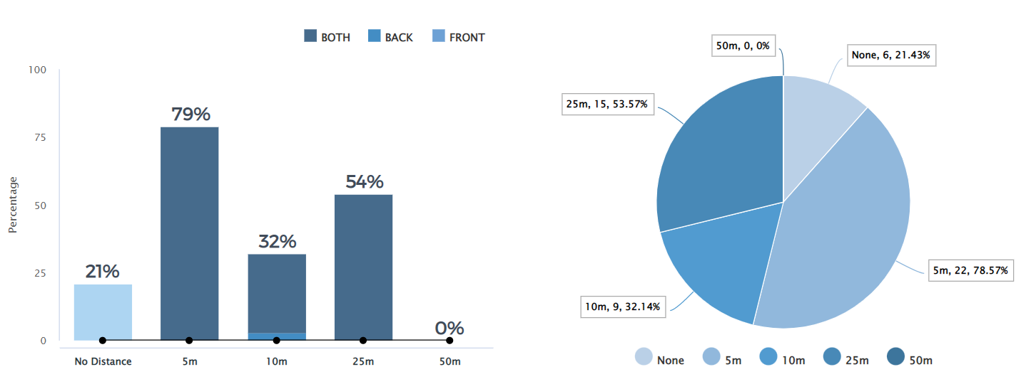
Swimming data class 6AP
Action Plan
Next Steps We are striving to improve our swimming data to ensure as many children as possible are achieving curriculum expectations by the conclusion of KS2. In order to secure this, we have developed an action plan as set out below.
Improving Swimming Data – Action Plan
Objective | Tasks | Success Criteria | Time Frame | Resources/Cost
To increase the amount of children leaving Year 6 having achieved National Curriculum objectives | Use Sports Premium grant to fund ‘top-up’/booster sessions (post Year 4/5) to ensure as many children as possible reach curriculum expectations. (To be ran in summer term – Year 6 children to attend extra swimming classes during summer term) | 60% of children leaving in Year 6 reach curriculum expectations when it comes to swimming. | Current Year 6 cohort did not meet this academic year with 57%. 60% of children need to be reaching curriculum standards by July 2023. | Rental of Ashton Pool complete with teachers - £85 per hour total of 12 hours -Transport to and from Ashton Pool £62 per return journey – 12 journeys

