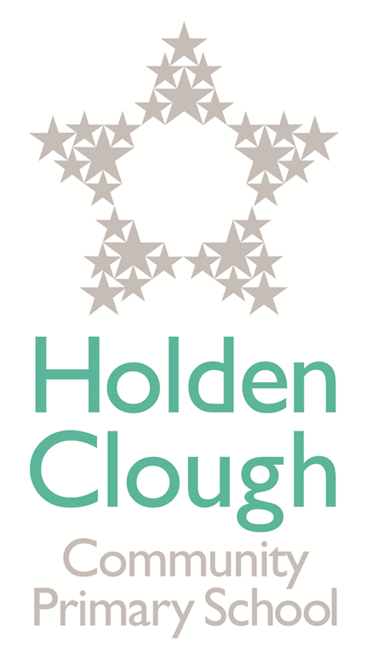

Music Policy
2021

Review Date: October 2022

Contents
1. Rationale and Aims ................................................................................................................ 2
2. Teaching and Learning Style .................................................................................................. 3
3. Differentiation ........................................................................................................................ 3
4. Children with Special Needs .................................................................................................. 3
5. Cross Curricular Links ........................................................................................................... 4
6. Equal Opportunities ……………………………………………………………………………………4
7. Health and Safety ……………………………………………………………………………………...4
8. Role of the Co-ordinator ………………………………………………………………………………4
9. Resources ……………………………………………………………………………………………..4
10. Assessment and Recording …………………………………………………………………………4

Rationale

This document is a statement of the aims, principles and strategies for the teaching and learning of music at Holden Clough Primary School. Music is concerned with the creative, aesthetic and emotional response to rhythmic combinations of sounds. Within our music lessons, children will be provided with the opportunity to compose, improvise, sing, create and perform. They will also learn to manipulate and evaluate their creations. This evaluation element enables pupils to develop skills in listening to and appraising their own work and that of other musicians and composers. This also helps them to understand the value and significance of Music in society.

Aims

Our curriculum aims to:

- To develop the creative potential of each child by providing challenging learning situations which encourage the development and communication of the child’s own ideas, experiences and feelings using a wide variety of expressive media.
- To increase the child’s sensitivity and curiosity about the environment and themselves through challenging their senses, imagination, perception and feelings.
- To provide opportunities for play, experimentation and visual representation.
- To talk about the work of other composers from a variety of cultural settings and visit places of interest in order to broaden their own ideas and knowledge.
- To develop self confidence, self esteem and positive attitudes towards each other, school and learning by providing opportunities for responsible self directed activities and personalised learning through which children can talk about their ideas and work and have outcomes acknowledged through display.
- To develop self awareness and emotional intelligence through activities which draw upon their personal experiences and feelings.
- To provide a visually stimulating environment which challenges their curiosity and excitement about the subject.
- To be able to evaluate and assess the work they make.
- The school should ensure that all children:
- Access a broad and balanced, enriching curriculum where they can show progression in the development of skills.

- Enjoy an active involvement in music.
- Have opportunities to learn about music from different times and cultures.
- Become visually literate and able to identify and apply the key elements of music.
- Develop the ability to analyse and make informed critical judgements about their work and the work of other composers using appropriate language.
- All pupils will be given equal access to the experience of music regardless of the gender, race or disability.

2. Teaching and Learning Style
School’s aim is to develop the children’s knowledge and understanding and skills in music . We also want to encourage children to investigate, make, explore, develop and evaluate ideas and to draw attention to good examples, to look at the work of composers linked to their class, have a good understanding of that composer for the year so to build up a bank of knowledge.

3. Differentiation
Children have differing ability in all of classes, and so we provide suitable learning opportunities for each child. We set tasks which are open ended that increase in difficulty using Dimensions Curriculum which is topic themed. We use a variety of grouping for a range of tasks as well as providing extra-curricular activities, for example, visits to the Bridgewater Hall, Royal Northern College of Music, Young Voices at M.E.N , POP UK concerts linked to PSHE. We also provide opportunities in school for children who show talent and aptitude in learning an instrument to be able to carry on and be taught be specialist music teachers weekly and at lunchtimes.

4. Children with Special Needs
Provision is made for children with Special Needs, which may be physical, cognitive, emotional, behavioural and assessment will be made on the difficulties experienced by the children. The use of music is used to build self-esteem and allows children to experience success and develop a positive attitude towards learning.

5. Strategies for Teaching
The Long term plans link to a broad topic themed based curriculum by following Dimensions Curriculum which gives details of each unit of work for each half/full term. Activities planned build up prior learning and help the children develop their skills, knowledge and understanding. Tameside music specialist Sue Green is covering other areas of the curriculum such as rhythm and drumming with both keystages-she has also linked her planning from Tameside Music to Dimensions Curriculum and Charanga. Children experience a wide range of activities and are able to learn about different composers. Activities are imaginative and enjoyable. Adriane Tomlin is a string specialist who teaches small groups of children in school and provides a lunchtime club for keyboard in KS2.The Music Co-Ordinator will teach across the year groups on a yearly basis in order to monitor coverage and provide CPD when needed.

6. Cross curricular links
Where appropriate, music will be used to broaden the children’s understanding in other subject areas, enriching their experiences. Dimensions Curriculum is a themed topic based curriculum, access to Charanga and YUMU and Tameside Music using specialist teachers.

Literacy –
In Literacy, children are encouraged to ask and answer questions, to ask and investigate other composers and their starting points. They have the opportunity to compare ideas, methods and approaches in their own work and that of other children, and to say what they think and feel about them. Listening and appraising music is an integral part .

ICT –
We use ICT to support Music teaching when appropriate, including Garage Band. Children are able to collect visual information to help them develop their ideas by using iPads to record their observations. They are also given the opportunity to use the internet to find out more about famous composers.

Personal, social and emotional development (PSHE) -
Within Music contributes to the teaching of some aspects and elements on PSHE as children are given lots of opportunities to discuss how they feel about their own work and the method and approaches used by others. They have the opportunity to meet and talk with other adults whilst undertaking their work. POP UK provide learning opportunities to practice and learn a wide variety of songs linked to PSHE across the whole school , culminating in a concert for children from all years to take part in and for parents to watch.

Spiritual, moral, social, cultural development -
Teaching children music gives opportunities to support the social development through the way of working with each other in lessons, grouping, respecting each other encourages cooperation and collaboration. Also it develops an understanding of different cultures and times through their work on famous composers.

Equal Opportunities -
Music follows the guidelines of the school’s Equal Opportunities Policy, regardless of gender, race or cultural background.

The Role of the coordinator
The Music coordinator is responsible for the development of the monitoring of Music to evaluate and review. They are also responsible for:
- Monitoring planning, progression and continuity.
- Specifying and ordering resources.
- Coordinating staff requests for ordering resources.
- Gathering evidence of displays and leading by example on Music board in the hall.
- Reviewing Tameside teacher’s plans -linking into Dimensions Curriculum with Sue Green.
- Pupil voice
- Staff meetings for updates, providing ongoing CPD.

- Teaching in all year groups over to year in order to assess and monitor learning.

Resources
Music materials and bought in and stored in boxes for both KS1 &2. All teachers are responsible for maintaining the tidiness of this and put instruments back. We use the planning and resource materials from Dimensions Curriculum enriched with Charanga for listening and appraising . School has purchased a licence which all staff have access to.
Assessment
Assessment will be recorded using the School’s data system-SIMS/New curriculum where the National Curriculum objectives are used. Children can be identified as Gifted and Talented from this and are offered opportunities to go for extra lessons.
The Music coordinator will review these assessments and monitor tracking from this data.

