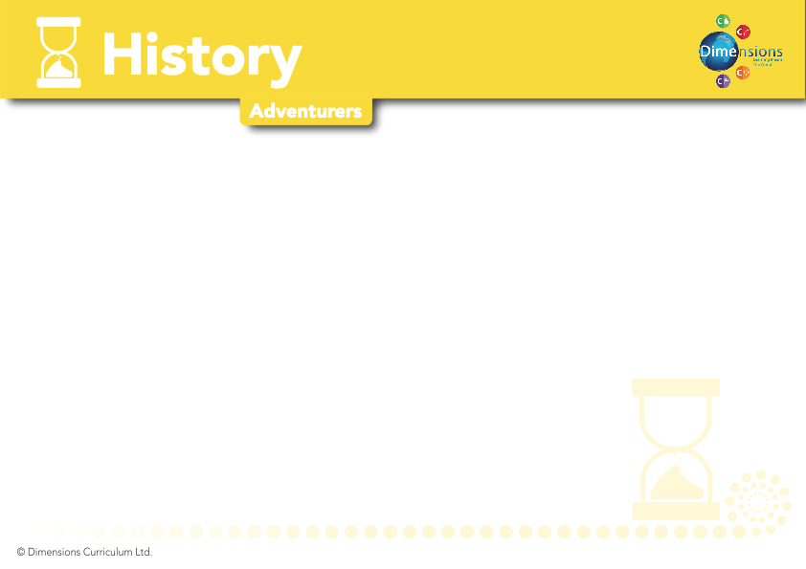

Y3-4

COME FLY WITH ME! AFRICA | UNDER THE CANOPY | ATHENS V SPARTA
Pupils should be taught about a non-European society that provides contrasts with British history  - To know the location of the continent of Africa and can identify its largest countries  - To know about some aspects of African culture  - To learn about the Benin Early Period | Pupils should be taught about a non-European society that provides contrasts with British history  - To understand where names come from and what they mean  - To understand the relationship between where we originate from and what our names mean  - To learn what it would have been like for the Mayans, living in the rainforest | Pupils should be taught about Ancient Greece  - To know the location of Greece  - To learn about the Greek Empire  - To understand the importance of Athens and Sparta  - To know about some of the important battles e.g. The Persian Wars  - To learn about Greek mythology  - To discover the legacy of the Ancient Greeks e.g. democracy and buildings
National Curriculum Objectives =

