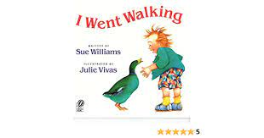
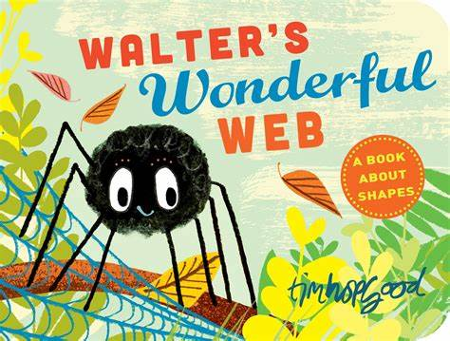
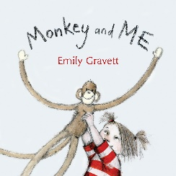
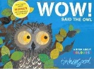
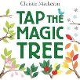
Planning a sequenced curriculum to ensure all children make progress and are ready for the next stage of their education.
Draft:June 2021

Nursery Curriculum
New EYFS Framework 2021
EYFS: Nursery Sequenced Curriculum - 2021 to 2022
New EYFS Framework
Age Related Expectations * Teaching and learning to be differentiated through short term planning, driven by assessment
Consolidation and revisit of key skills, knowledge and understanding through continuous and enhanced provision
Area of Learning | Autumn 1 | Autumn 2 | Spring 1 | Spring 2 | Summer 1 | Summer 2
Overarching Theme | Happy to be me | Autumn / Celebrations | Animal Kingdom  Come fly with me Asia | Out and about/ no place like home | Growing | Living things
Links to dimensions curriculum | Communication | culture | Conflict | Conflict |  | Conservation
Planning around a quality text:  To be chosen following children’s interests. | 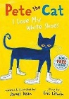 |  | 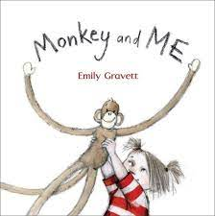 | 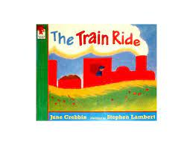  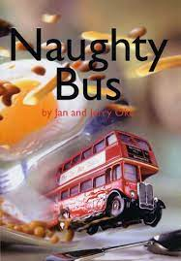 | 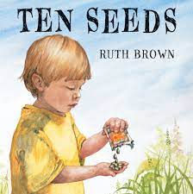  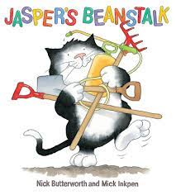 | 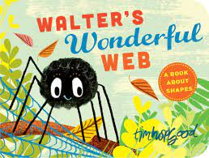  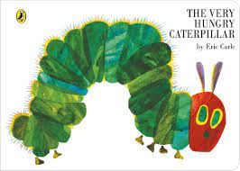
Linked texts | - My Body  - My mum and Dad make me laugh  - When I Grow up  - My world your world  - Lulu  - Monkey Puzzle  - Nursery Rhymes | - Owl Babies – Martin Waddell  - Ramadan  - Christmas festivals around the world  - Dear Santa  - Leaf man  - Nursery Rhymes  - The Gruffalo  - We’re going on a leaf hunt | - Dear Zoo  - OI Cat  - Oi dog  - Oi Frog  - Nursery Rhymes | Nursery Rhymes  - Easter festivals around the world  - Maisy’s Chinese New Year  - Spots Easter Basket | Nursery Rhymes  - The Tiny Seed  - Sam Plants and Sunflower  - Titch | Nursery Rhymes  - Caterpillar and the bean  - Butterfly  - What the ladybird heard
Possible line of enquiry/themes/interests | - Role play a home  - Harvest | - Bonfire night  - Children in need | - Changes in environment  - Mother’s Day  - Compare Asia to England  - Food from around the world | - Toys and movement | Planting and gardening | - Caring for animals  - Minibeast environment/hunt
Trips/Visitors  Enrichments | Visitors:  - New baby  - Mums / dads  - Pet/s | Trip:  - School grounds  - Forest school /bonfire experience | - Farm visit  - Small world wild animals/farm animals  - Visitor from another country eg china | - Walk around the school grounds  - Police visit | - Garden centre | - Life cycle of a caterpillar  - Mini beast visitor
Celebrations / Festivals / Special Events | - Birthdays | - Birthdays  - Harvest Festival  - Diwali / Hannukah  - Christmas  - Halloween | - Chinese New Year | - Easter
Parental involvement | Staggered start  Parents meeting | Christmas activity morning  Nativity/play |  | Easter Activity morning | Sharing books with children | Parental involvement
Key Vocabulary  More vocab in short term plans | Past and present  Before, after, next ,now,day, night, today, grow, change, old young, new, same, different, family, photograph  Body parts- face teeth knees body back skin family names | Leaves leaf rustle woodland animals | Celebrate,  country, farm, hills, zoo, wild | Transport, Train bus push pull float sink  occupations police job, | Planet, seeds, decay, growth, stem leaf, growing, allotment, recycling | minibeast caterpillar life cycles egg grow change butterfly
Rationale | Child centred  Supports transition from home  To develop language and comprehension through high quality story | To show curisosity about the world around them  To appreciaite different culutres in their community and the world around them  To ask qustions and relevant comments | To look at vocabulary to access a wider curriculum  To compare countries and see different places  Immerse children in a rich environment of words, | To understand their community | To be able to invetigate and ask questions | To Enhance children’s sense of responsibility for the care of their own environment and the impact it has on the whole world

