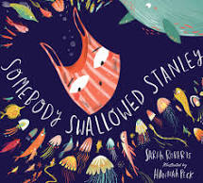
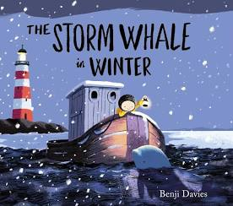
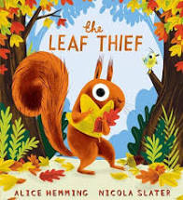
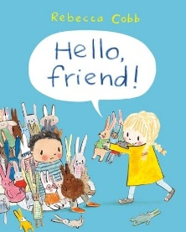
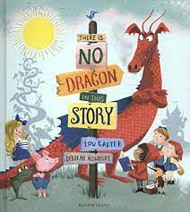
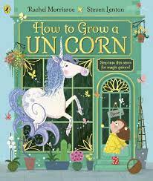
Holden Clough Reception Curriculum
New EYFS Framework 2021
Planning a sequenced curriculum to ensure all children make progress and are ready for the next stage of their education.

EYFS: Reception Sequenced Curriculum - 2021 to 2022
New EYFS Framework
Age Related Expectations * Teaching and learning to be differentiated through short term planning, driven by assessment
Consolidation and revisit of key skills, knowledge and understanding through continuous and enhanced provision
Builds on skills from Nursery
Area of Learning |  | Autumn 1 | Autumn 2 |  | Spring 1 |  | Spring 2 |  | Summer 1 |  | Summer 2
Overarching Theme |  | Happy to be me | Autumn / Celebrations |  | Animal Kingdom |  | Out and about/ no place like home |  | Growing |  | Living things
Links to dimensions curriculum |  | Communication | culture |  | Conflict |  | Conflict |  |  |  | Conservation
Planning around a quality text:  To be chosen following children’s interests  . |  | 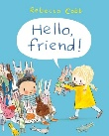  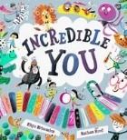 | 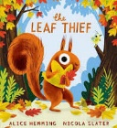  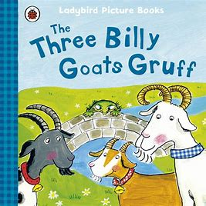 |  | 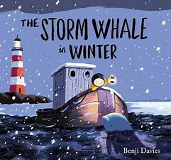  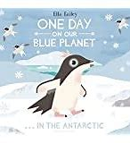 |  | 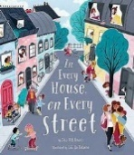  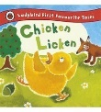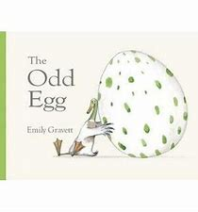 |  | 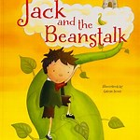 |  | 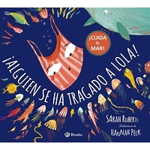  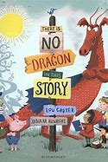
Linked texts |  | - Families around the world  - Room on the room  - My friends and me  - All welcome hear  - Pete the cat rocking my school shoes  - The colour monster  - Birthdays in many cultures | - Stanley’s Stick  - Tree  - A year in the forest  - Birthdays in many cultures  - A Scarecrows Wedding |  | - Penguin  - The storm Whale  - Home for a penguin Home for whale |  | - Non- fiction chick book  - Home  - Look and say what you see in a town  - Home from the past  - Toys in space/ but martin |  | - Bee books  - Oliver’s vegetables/ fruit salad |  | - Dear Greenpeace  - One day on our blue planet  - Wendell  - Fantastic fish
Possible line of enquiry/themes/interests |  | - Diversity  - Halloween  - Dentist oral health  - Healthy eating | - Christmas  - Diwali  - Eid  - Bonfire night  - Artist Andy Goldsworthy  - Baking |  | - Chinese New Year  - Small world wild animals  - Winter  - Artic animals |  | - Easter  - Transport  - Small world space |  | - Planting  - Naming planets  - Observational drawing  - Sunflowers Vincent van Gogh |  | - Caring for animals  - Conservation looking at plastics  - Mini beasts  - Pirates
Parental involvement |  | Staggered start  Parents meeting  - Reading workshop including phonics | Christmas activity morning  Nativity/play |  |  |  | - Easter Activity morning |  | - Sharing books with children |  | - Parental involvement
Trips/Visitors  Enrichments |  | Visitors:  - Nurse/Dentist  - Grandparents  Role play clinic | Visitors:  - Rangers from park bridge  Trip:  - Park / Woodland  - Eg Delamere forest |  | - Baking cakes  - Cooking pancakes  - Animal experiences workshop  - Musicians/art gallery |  | - Living eggs  - Walk around the estate  - Paramedics/firefighters  - Farmers |  | - Visit from Mrs Berry about looking after plants |  | - Blue planet  - Vets
Celebrations / Festivals / Special Events |  | - Birthdays  - Rosh Hashanah | - Birthdays  - Bonfire night  - Harvest Festival  - Diwali / Hannukah  - Christmas |  | - Mother’s Day  - Shrove Tuesday  - Valentine’s day  - Chinese New Year |  |  |  |  |  | - Transition to year one
Key Vocabulary  More vocab in short term plans |  | History, past present, future, long ago, extended family members, toddler, adult, younger older, occupations dentist doctors’ parts of the body elbow bones heart freckles skin chest | Wood land Geography, cultural celebrations, places of worship, religion, believe  Hibernation name of woodland creatures  Autumn season |  | features of the environment, island forest jungle, woodland mountain, map,  seasons |  | Occupations paramedic etc, features of environments road map location life cycle egg hatch chick beak feathers animal mums names space words local town village |  | Plant and trees branch bark seed petal stem roots tree parts seasons sunshine etc |  | Ocean, pollution animal names aquarium
Rationale |  | Child centred  Supports transition  To be able to self-regulate and understand their emotions  To understand their feelings  Looking at diversity  Different kinds of families  History of families  To develop language and comprehension through high quality story | Looking at changes in the environment  To extend vocabulary  To develop language and comprehension through high quality story  To develop a life long love of reading |  | To look at vocabulary to access a wider curriculum  To compare countries and see different places  Immerse children in a rich environment of words,  To Foster a sense of awe and wonder about the world in which they live To develop an appreciation of other people, their communities and their traditions |  | To develop language and comprehension through high quality story  To understand their community  To develop an appreciation of the world in which they live. These include where they live and their school, their local community and interesting local places |  | To develop language and comprehension through high quality story  To Cultivate children’s curiosity about how and why things work and how things change |  | To develop language and comprehension through high quality story  To Enhance children’s sense of responsibility for the care of their own environment and the impact it has on the whole world
Key concepts, skills and knowledge | See core knowledge mats
Happy to be me | Autumn and celebrations |  |  | Animal Kingdoms |  | Out and about no place like home |  | Growing |  | Living things
History  Family- understanding how every family is different and understand about the past  Children will learn about things that make them unique  About similar or differences to their friends and family  Children will be able to show an interest in lives of people who are familiar to them.  To talk about significant event and their own experiences such as special times eg birthdays weddings  My place in history  There is a past before I was born  PSE  Children will learn to play alongside others  How to resolve conflicts  To solve problems  To listen and respond  To speak to others about own needs.  PE/science  Children will learn about healthy eating and why need to brush our teeth  How to keep healthy | Science  The characteristics of the four seasons  The characteristics of different weather types  To know why leaves, change colour What happened to tress in Autumn  Looking at similarities and differences and classifying  Make observations  History/RE  Why are celebrations special  To understand that traditions are a special time that happens  A custom is a way of doing things.  Children will learn about each other’s faiths and cultures  To respect each other  To use the language to describe how they celebrate  Guy Fawkes looking at a person from the past and understand  Historical events and people have a significant place in our history |  |  | Geography  The names of different countries around the world Different countries have different key features  children will learn about the features of specific locations  Talk about the key features of different places and different countries and compare to ashton  Talk about what it is like to live in another country  Compare where animals live  Continue with the Characteristics of seasons eg Winter  Children will be able to talk about different habitats  Science  Winter and looking at materials such as water frozen what happens when warm? |  | Geography  Children will be able to  Where I live  The key features of where I live  About the significant places within my local community  How to get from one key place to another  The vocabulary I need to use to direct others  People I know have different customs and traditions People in different countries have different customs and traditions  History  children will learn about how things have changed over time using transport and housing  Skills  Gather information from different sources  Draw, read and follow maps  Science  About life cycles  What living things need to survive |  | Science  How does it grow?  children will learn about changes and living things  The names of the different parts of plants  Skills  Test ideas  Make predictions  Sort and classify  Measure |  | Geography  Human actions can help and destroy the planet.  To understand about plastics destroying the world.  How can we save the planet?  What is under the sea?  Science  classifying animals under the sea  Looking at materials and how they are affecting the sea life.

